Supporting your child with Mental Health

Please see the information on the campaign below that will be going on throughout the summer.

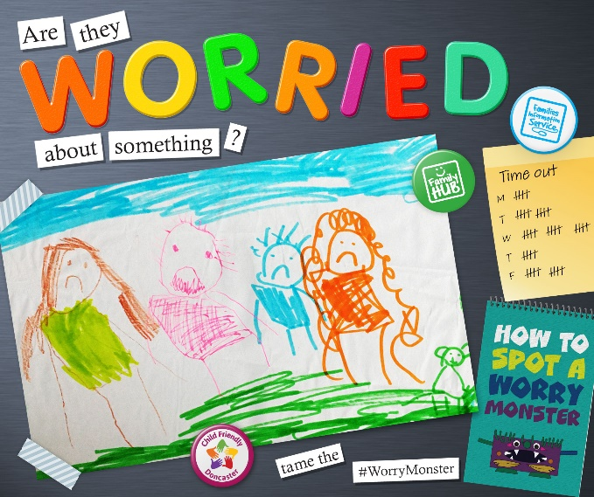

Starting next week, we will launch a new campaign aimed at Doncaster’s parents/carers, to provide them with information, advice and guidance on how best to support their child with their mental health. Whilst this is an important issue all year round, it felt like a particularly good time to shine a light on support available, due to the coronavirus pandemic and the challenges and upheaval that this has created for some children, particularly as we look ahead to the summer holiday. We know that you share these concerns and have been doing as much as you can to support children in your school.

In the coming weeks, we will be posting various messages on our social media channels (Facebook, Instagram and twitter) targeting parents/carers of children around the age bracket 3-11 years. Central to the campaign is our newly created webpage www.doncaster.gov.uk/worrymonster which contains all the information, advice and guidance on support available locally through our partners (and also some national support).

The campaign shares some of the signs to look out for in children who are feeling worried and/or anxious, and suggests some ways in which parents/carers could support their child with their mental health, backed up by lots of helpful resources and further information to help parents/carers to do this.

