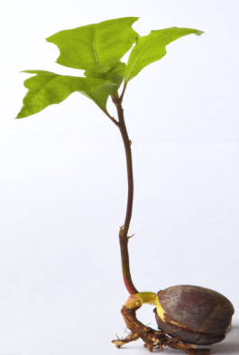

**A New Pasture Curriculum**

The Coronavirus pandemic occurred extremely swiftly and impacted across every layer of society without discrimination The country moved to a period of lockdown, initially schools only remained open to children of key workers or vulnerable and families were forced into extraordinary circumstances. The situation has been life changing and the social and emotional development of our children will have been disrupted by trauma loss and change impacting on their wellbeing. At New Pastures we have reviewed current literature in order to understand how to support our pupils post pandemic to return to school. As we support this return, gradually and safely, our attention shifts much more towards helping children come back to us and each other with a healthy mind and body and we will provide a balanced curriculum of how to learn best with what to learn.  We will follow a nurturing principal and use the five key levers to recovery model taken from the work of Barry Carpenter (2020),

* The social and emotional development of our children will have been disrupted by trauma loss and change. With this in mind our curriculum will be based on the 5 levers of the recovery curriculum (Carpenter, 2020), use the principles of nurture and be A New Pasture healthy mind and body curriculum

* **Lever 1: Relationships** – we can’t expect our pupils to return joyfully, and many of the relationships that were thriving, may need to be invested in and restored. We need to plan for this to happen, not assume that it will. Reach out to greet them, use the relationships we build to cushion the discomfort of returning.
* **Lever 2: Community** – we must recognise that curriculum will have been based in the community for a long period of time. We need to listen to what has happened in this time, understand the needs of our community and engage them in the transitioning of learning back into school.
* **Lever 3: Transparent Curriculum** – all of our pupils will feel like they have lost time in learning and we must show them how we are addressing these gaps, consulting and co-constructing with them to heal this sense of loss.
* **Lever 4: Metacognition** – in different environments, children will have been learning in different ways. It is vital that we make the skills for learning in a school environment explicit to our pupils to reskill and rebuild their confidence as learners.
* **Lever 5: Space – to be, to rediscover self, and to find their voice on learning in this issue**. It is only natural that we all work at an incredible pace to make sure this group of learners are not disadvantaged against their peers, providing opportunity and exploration alongside the intensity of our expectations.

INTENT

* We will strive to make our school environment as safe as it possibly can be. It will be a secure and welcoming base where children are helped to manage their own behaviour and feelings and increase their capacity to develop coping strategies
* We will re-build our positive relationships- encouraging children to express their thoughts, questions, and feelings. Children will be able to socialise and work with their friends and with adults in a new routine with new expectations. We will work on our learning behaviours of collaboration and independence
* We will ensure that our school offers a nurturing approach. We will equip children with the emotional tools for a happy, healthy, and successful life and develop strategies that will serve them well beyond the current crisis. We will work on our learning behaviour of resilience. Children will know it is ok to make mistakes, learn from them and not be afraid to start again.
* Our curriculum will be relevant and engaging to motivate children in their learning. We will plan from their experiences and follow a cross curricular approach. We will work on our learning behaviours of creativity and engagement where thinking skills are developed
* We will focus on a healthy body and mind, promoting physical activity and engage children with outdoor learning
* We will have high expectations in everything we do. Children work on our learning behaviour of perseverance, working hard and making every piece of learning better than the last
* Our learning will be co constructed to reinforce the key basic skills of mathematics, reading, writing spelling and grammar. Assessment and feedback will be used carefully to identify particular areas where pupils may have forgotten or misunderstood key concepts. Pupils will be identified who need additional support and programmes put in place.

