Class Seven home learning Reading and writing Weeks commencing 01.06.20 and 08.06.20
We would have been reading The Railway children in class. I have enclosed a link to a free PDF version; there is another link to audio versions of the chapters. This is a very challenging, classic text that links with our history topic which is about the history of railways. Reading for enjoyment is very important. Please encourage your child to read and to write a few sentences about what they are reading in their reading diary.
http://dl9.irlanguage.com/Railway-Children/Railway-Children-L3-Orginal.pdf
https://librivox.org/railway-children-by-e-nesbit/
Reading Class Text – A little of anything, everyday.
It is important that the children are able to practice a range of reading questions. We use VIPERS to remind ourselves of the different question types. Vocabulary, Infer, Predict, Explain, Retrieve and Summarise.
Banded Readers
I have registered the class with Oxford Owl. If your child logs on to this site they can use our class log in- Newpasturesclass7 Password- Rowling. They can find ‘e’ readers on different books bands.
Spelling- Non-statutory lists.
Please use the spelling lists provided to do a spelling test. We usually aim to do twenty a day over a week. Your child can then work on the ones they are unsure of. The lists came out in the original learning packs.

Writing:
Vocabulary-to use a range of ambitious vocabulary.
Punctuation-to use a wide range of punctuation
w/c 01st June | This week, you will write a story based on this picture. 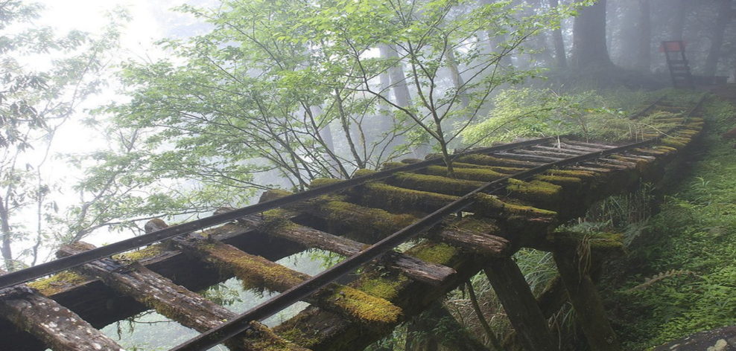
Day One | Do now: list five synonyms for ‘old’.  Main task: Describe what you can see in the picture. You could make a bullet-point list or write around a copy of the picture. You will be able to use this description in your writing task on Friday.  Final task: Tell me why you are proud of your work.
Day Two | Do now: Can you place the missing bracket in the sentences below? ! A strange shape that seemed to be moving rather quickly ) could be seen on the old, rickety track. ! The noise (which was deafeningly loud echoed through the woods. Can you write a sentence that contains brackets?  Main task: Read the opening section of the story.  It had been many years since the shrill shriek of a steam train puffing along the track had been heard in these parts. The Northern Railroad had been discontinued after the great disaster on June 11th, 1911. Ever since that day, the Railroad company had been nothing but a distant memory, a story to be told around the campfire late into the night. As the group sat around their newly constructed camp, listening to the crackle of the flames as they licked up into the night, their minds wandered back to the stories they had heard from their fathers. So absorbed were they in the moment, and the mesmerizing glow of the fire, that it was hard to tell if the shrill shriek coming from the distance was part of their imaginations…  Rewrite this section adding in a sentence with brackets.  Final task: Double check your brackets!
Day three | Do now: What do you think happens next in the story?  Main task: Plan your story. You should be aiming to write between four and six paragraphs.  Final task: Create a storyboard or comic strip for your story.
Day Four | Do now: Can you make these sentences more interesting by using add spice openers?  They sat in the woods. They lit a fire. They built a camp. They told stories. Then they heard a strange noise.  Main task: write your story.  It must include:  Brackets  A detailed description of the scene (at least four sentences)  Add spice openers.
Day Five | Do now: Read your story. Tell me one great thing and something you could improve.  Main task: You need to make five revisions which improve your story. Rewrite the story and underline the improvements.  Final task: Tell me how the changes have improved your work.
Week Two  08th June | 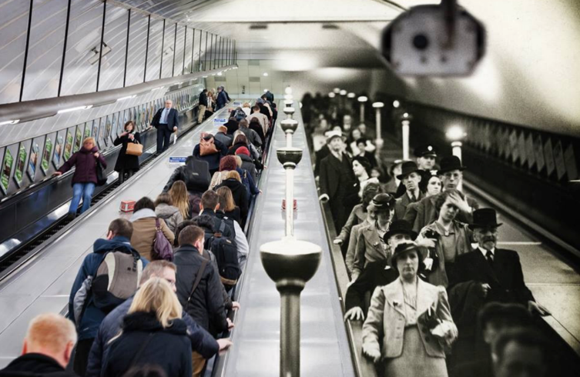  This week, you will write another narrative. Imagine you have left something on the platform. As you go down the escalator, you are transported into the past…
One | Plan your story.  Part one – What did you forget? What happens as you return to the platform?  Part two – Introduce a problem faced by your character.  Paragraph three – What happens next?  Paragraph four – Resolve the problem.
Two | Do now: How do you think the lives of the people in the picture are different?  What can you tell about a person by looking at the clothes they wear?  Do you think people that lived 100 years ago had better or worse lives than us?  https://www.bbc.co.uk/bitesize/topics/zwwp8mn/articles/z3nfw6f  Main task: Write the first part of your story. You must include three expanded noun phrases. Challenge: Can you include two in the same sentence? The link above will remind you about expanded noun phrases.  Final task: Underline your expanded noun phrases.
Three | Do now: Can you write a sentence that uses three adjectives before a noun? Can you use a comma to separate the adjectives (because they are in a list)?  e.g. The smart, intelligent and elderly man wore a tall, black hat.  We call this a triplet.  Adjectives helps our reader to imagine the scene as we see it.  Main task: Write the second part of your story. Really focus on adding adjectives to build up the descriptions. You should use some single adjectives, two adjectives and a triplet at different points.  Final task. Highlight or underline the adjectives.
Four | Write your story.  It must include:  Expanded noun phrases;  A range of adjectives;  Four different types of punctuation; and  Ambitious vocabulary.
Five | Analyse your narrative. Have you met the learning criteria? Explain how. You could take a photo of your work, stick it into the middle of a piece of paper and analyse around it. Or you could provide examples by quoting parts of your work.

