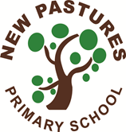

**A message from Mrs.Belnavis**

**26.6.20**

Dear families,

Well yet another busy week has gone by. I hope you have managed to enjoy the sunshine and spend time with your families as some of the lockdown restrictions have been released. The government will be sending guidance to us next week about opening schools in September. Following this I will be writing to you with details and explaining what will be happening in our school. Class teachers will be in touch to arrange a telephone conversation with children before the end of term and you will also receive a report and details of classes. Once again I have seen some great home learning, well done everyone.

Lucas in C1 has been working so hard with his home learning. He has been making symmetry pictures linked to minibeasts and he has been looking at the life cycle of minibeasts. He has some caterpillars at home and he has been watching their life cycle. Well done Lucas!

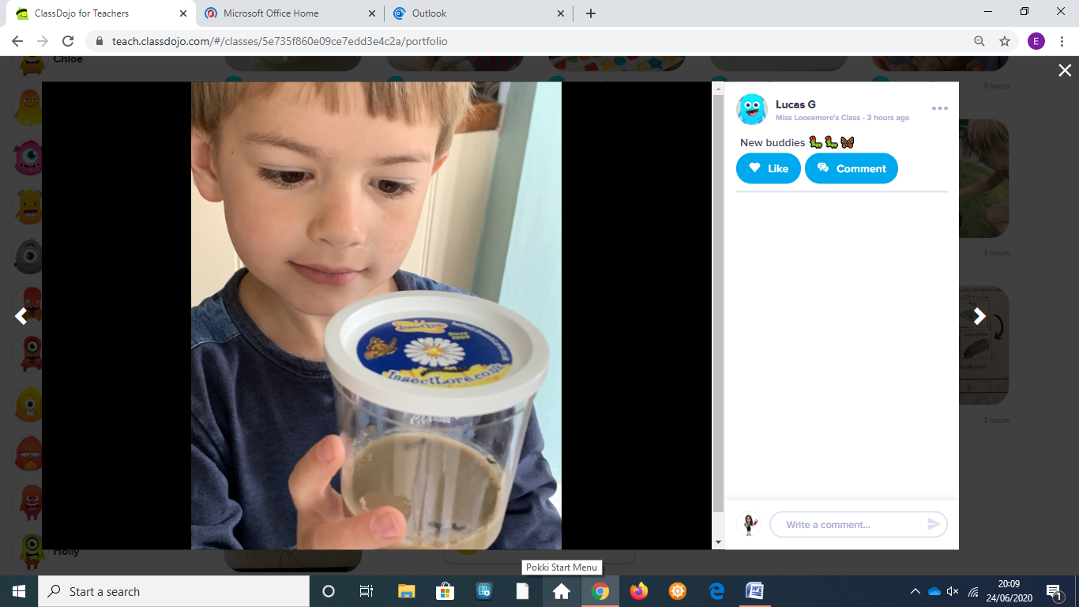 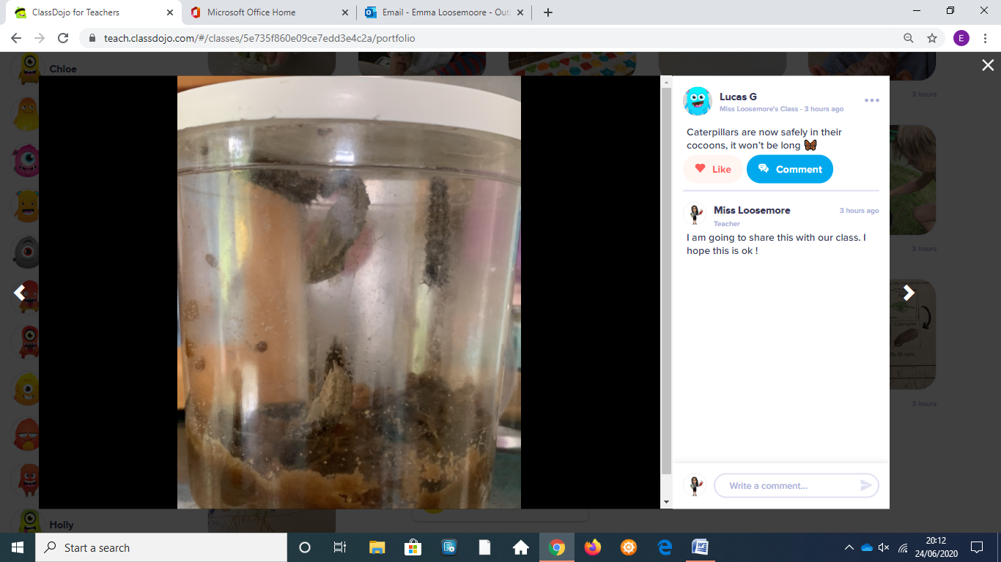

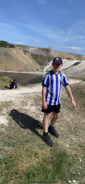

James in C9 has been a superstar engaging with his home learning and also being a big help to his mum helping her looking after his little brothers

That`s great James, well done!

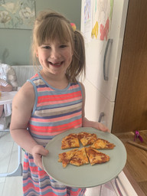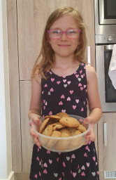

So far Amelia and Emilia in C4 are our ‘Epic Books’ reading Champions. Right from the start of Lock Down, both girls have been avidly reading the books and completing the book quiz at the end. Between them they have read 247 books! That is 20 hours of reading!

Well done girls- that`s fantastic!

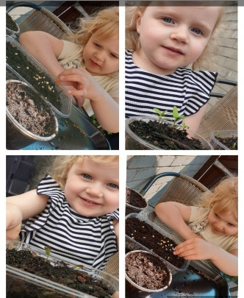

Phoebe in nursery has been looking after the seeds she has planted.  Mrs Haycock said she was so proud of her efforts.

I am sure you will enjoy eating your vegetables. Well done Phoebe 😊

Seb in C3 has been keeping really fit and healthy while school has been closed. He has been finding out about the local area and learning how to spot different birds. That`s great Seb!

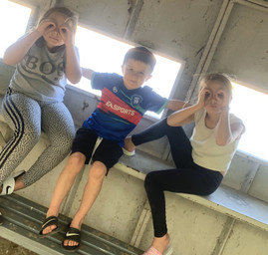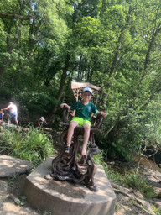 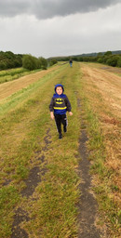

Mrs. Brennan told me that Abigail in C7 has been working very hard on a variety of learning at home. Well done Abigail- I am sorry I didn’t see any photographs.

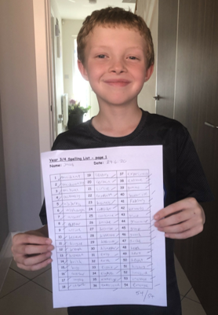

Jacob in C6 has fully engaged in the home learning and has especially enjoyed the Egyptians topic.  He scored full marks in his spelling test.  Well done, Jacob!

Mrs Mason told me she was so impressed with Daisy in C2! She began writing to residents in a care home as part of the My Dear New Friend Literacy Trust project a few weeks ago. She has been letting them know what she has been doing during lock down and I know that her letters have really lifted their spirits! Well done, Daisy! That is so lovely.

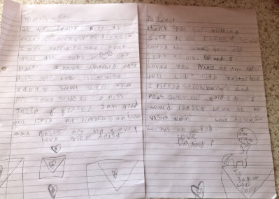

Ruby in C5 has been practising measuring and put her skills to good use by helping to bake this cake for her dad for Father’s Day! Well done Ruby, it looks delicious!

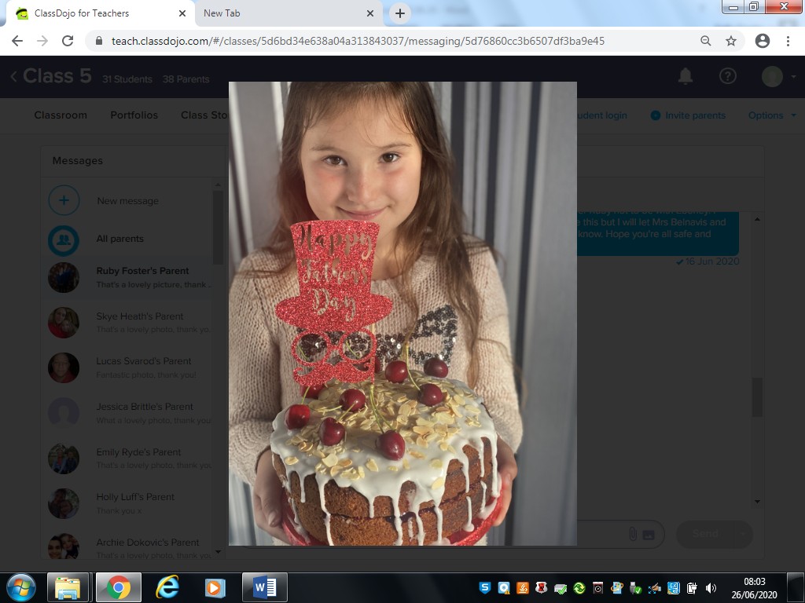

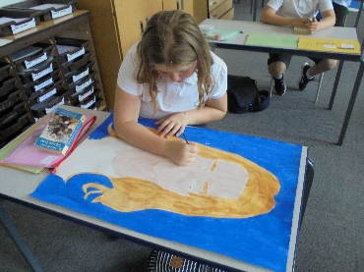

Yves in C8 came back into school this week and did a wonderful self- portrait for display. It looked great Yves.

Thank you for sharing your learning with me everyone .